Name: Abhinay P
Domain: Data Analyst
Project: Twitter Analytics Dashboard-Power BI
Task 6: Analyze tweets to show a comparison of the engagement rate for tweets with app opens versus tweets without app opens. Include only tweets posted between 9AM and 5PM on weekdays and this graph should work only between 12PM IST to 6PM IST and 7AM to 11AM apart from that time we should not show this graph in dashboard itself and tweet impression should be even number and tweet date should be odd number as well as tweet character count should be above 30 and need to remove tweet word which has letter ‘d’.
Data preparation and filtering approach:
To prepare the data, tweet text was first processed to remove only those words containing the letter ‘d’, while retaining the rest of the tweet. This cleaned version of the text was then used to calculate the tweet character count, ensuring that character-based filtering was applied to the correct textual content.
Tweet timestamps was converted to IST to accurately evaluate weekday constraints and time-based conditions. From the timestamp, the tweet date and posting hour were derived to support odd-date validation, weekday filtering, and time-window restrictions. Tweets were also categorized based on whether they resulted in at least one app open, enabling comparison between tweets with app opens and without app opens.
Conditions and filters applied:
The visualization includes only tweets that satisfy all of the following conditions simultaneously:
- Tweet posted on a weekday
- Tweet posted between 9Am and 5PM
- Visualization visible only during: 7AM to 11 AM IST and 12PM to 6PM IST
- Tweet impressions are an even number
- Tweet date falls on an odd-numbered calendar day
- Tweet character count is greater than 30 after removing the word containing letter ‘d’
Visualization design:
A clustered column chart was used to compare the average engagement rate between two categories:
- Tweets with app opens
- Tweets without app opens
Result and observation:
After applying all conditions, the visualization displays only one bar, representing tweets without app opens. No bar appears for tweets with app opens. This outcome indicates that, within the dataset, no tweets with app opens satisfied all filtering criteria
Simultaneously. The absence of the second bar is therefore not a visual or calculation error but a direct result of the strict business rules applied.
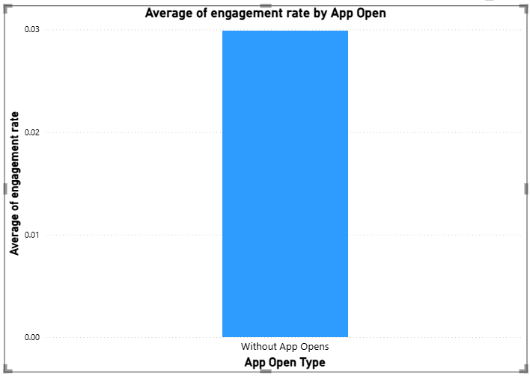
The presence of a single bar highlights how layered constraints are, particularly time-window restrictions, weekday filtering, text cleaning, and parity checks can significantly reduce the qualifying dataset. The result confirms that the filtering logic has been implemented correctly and that the dataset does not contain comparable tweets with app opens under the given conditions.
Conclusion:
This analysis demonstrates the importance of enforcing business rules consistently in data visualization. Although the initial goal was to compare engagement rates across two categories, the final output reflects the reality of the dataset under strict constraints. The single-bar result provides a valid analytical insight: under the defined conditions, engagement activity occurred only for tweets without app opens.

